return type in Java

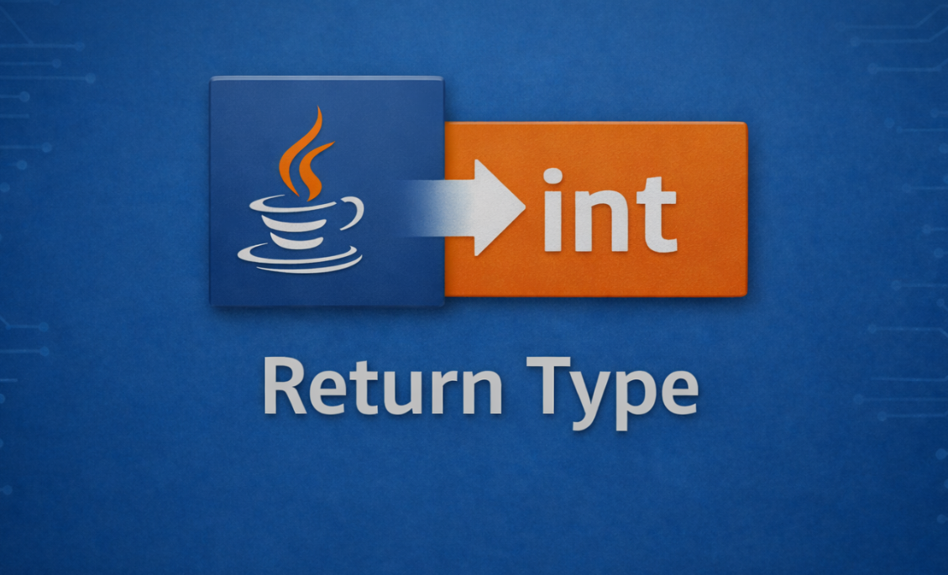

1. What is Return Type?
Return type in Java defines the type of value a method sends back after execution.

Example
int add(int a, int b) {
return a + b;
}
Here:
- int → return type
- Method returns an integer value

🔹 Another Example
String getName() {
return "Omii";
}
✔ Return type = String
✔ Returned value = "Omii"

🔹 Key Points
✔ Defines method output type
✔ Must match the returned value
✔ Helps reuse method results
✔ void means no return

2. Types of Return Types
1. Primitive Return Type
What is it?
When a method returns basic data types
Examples:
Int , long , char , boolean
Example
int getNumber() {
return 100;
}
double getPrice() {
return 99.99;
}

Returns single value
Stored directly

2. Non-Primitive Return Type
🔹 What is it?
When a method returns an object or reference
Examples:
Example :
String , Arrays , Class Objects

String getName() {
return "Omii";
}
3. void Return Type
"void in Java indicates that a method performs an action but does not return any value."

Method returns nothing
void showMessage() {
System.out.println("Hello Java");
}

Return Statement
Used to send value back to the caller
return value;
Example:
int square(int num) {
return num * num;
}

🔹 When to Use void?
✔ When you don’t need result
✔ When method performs action only
✔ When output is directly shown (print)

4. Important Rules
Return type must match value
Wrong:
int getData() {
return "Hello";
}
Correct:
String getData() {
return "Hello";
}
void method cannot return value
Wrong:
void test() {
return 10;
}
✔ Correct:
void test() {
return;
}
Multiple return statements allowed
int check(int num) {
if (num > 0) {
return 1;
} else {
return -1;
}
}
5. Memory Level Understanding
"When a method returns an object in Java, it returns the reference stored in stack, pointing to an object created in heap memory."

When a method is called:
- It goes into stack memory
- Executes the code
- return sends value back
- Method removed from stack
int result = sum(2, 3); // result = 5

🔹 Key Points
✔ Objects are always created in heap memory
✔ References are stored in stack memory
✔ Method returns reference, not actual object
✔ Local variables (like s) are destroyed after method ends
✔ Object survives if any reference exists
✔ Garbage Collector removes unused objects

6.Advanced Concept (Returning Object)
“Returning an object in Java means a method returns a reference of a class instance, allowing multiple data values to be accessed together."

class Student {
String name;
}

Student getStudent() {
Student s = new Student();
s.name = "Omii";
return s;
}

🔹 Key Points
✔ A method can return an object of a class
✔ Return type must be the class name
✔ Java returns reference, not actual object copy
✔ Object is created in heap memory
✔ Useful for returning multiple values together
✔ Helps in real-world modeling (Student, Employee, etc.)
✔ Common in frameworks (Spring, APIs, etc.)

